# Specific Cost

# System Costs

Total system costs for electrification scenarios are higher than technology mix scenarios. Reason for that is the difference in electricity demand. Technology mix scenarios has lower electricity demand than EL. In addition to that with increasing co2 mitigation target cost increases

(here put stacked bar plots of demand and budget)

Put agraph which shows demand and budget of scenarios and wrt EL 95 scenario

# Feasible Spaces

(production plotların max ve minini çizdir)

* 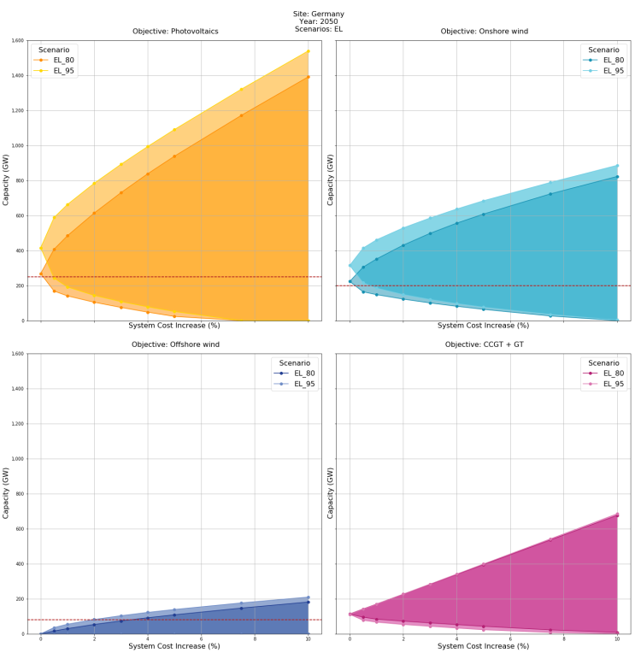Feasible spaces of objected Technologies are wider for more ambitious CO2 scenarios. Reason for that

Reason: Because minimum cost solution of more ambitious CO2 target solutions are higher, therefore percentage allowances yields more money. For same percentage increase on minimum cost more capacity can be build

If the same cost allowances were taken for different CO2 targets more ambitious scenarios would yield to a tighter feasible space.

Policy:

* For all scenarios minimum cost solution tends to build more PV and wind onshore capacity than socio technical limit.

Reason:

* Difference between feasible spaces of different CO2 targets are lower for TM scenarios

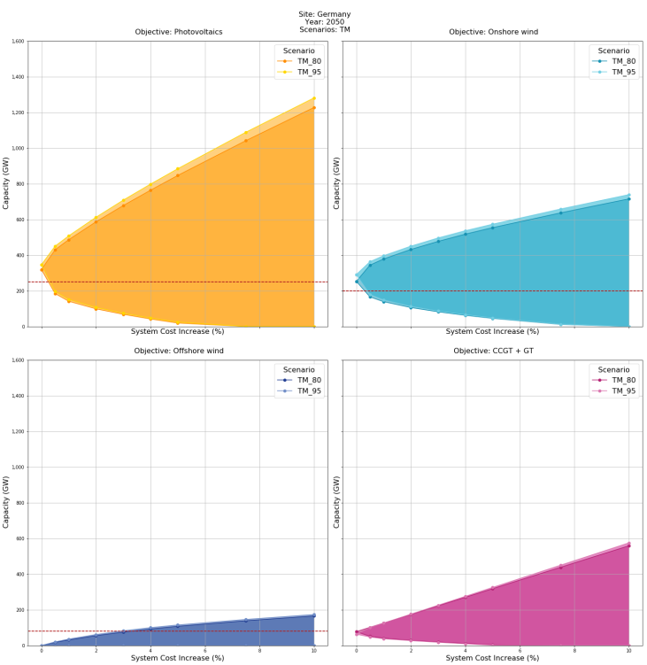Reason: It can be because cost difference between 95 and 80 scenrion are lower for TM scenarios.

## Slacks Needed to avoid technologies:

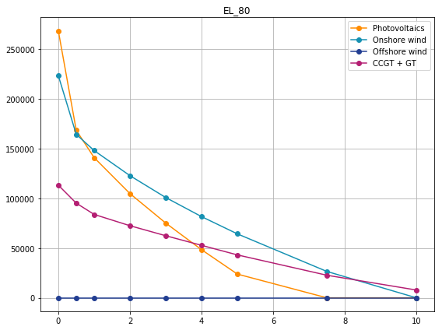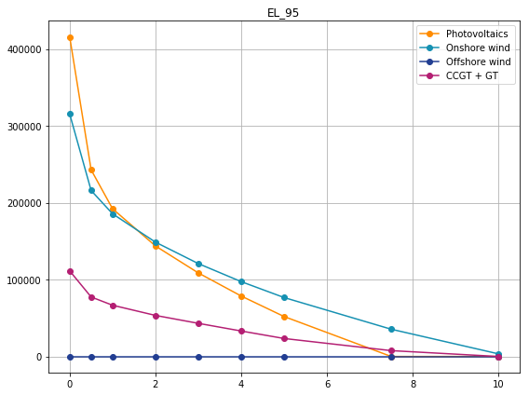

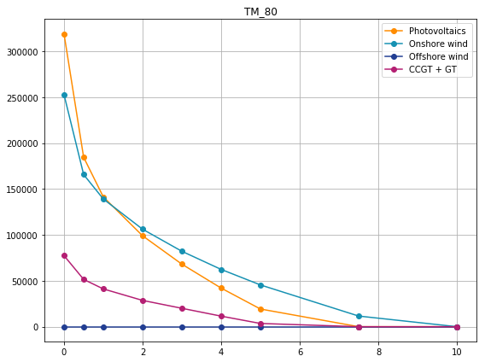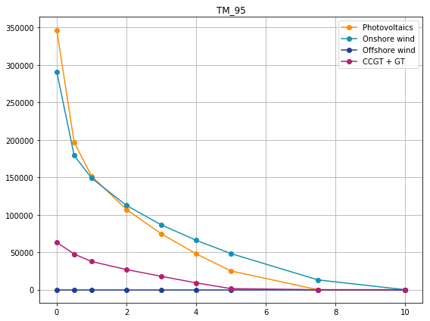

|  |  |  |  |  |
| --- | --- | --- | --- | --- |
|  | EL80 | EL95 | TM80 | TM95 |
| PV | 7.5 | 7.5 | 7.5 | 7.5 |
| On | 10 | 10 | 10 | 10 |
| Off | 0 | 0 | 0 | 0 |
| Gas | >10 | 10 | 7.5 | 5 |

* With a 7.5 % deviation from minimum cost it is possible to avoid PV panels.
* For Onshore wind this deviation increases to 10 percent of minimum system costs.
* Offshore wind turbines can be avoided without any cost trade off
* Relative cost of traditional gas turbine power plants phase out, costs less for technology mix scenarios (lower electricity demand, lower CO2 budget). Also relative cost of gas turbine phase out decreases when CO2 target increases

# Bar Plot

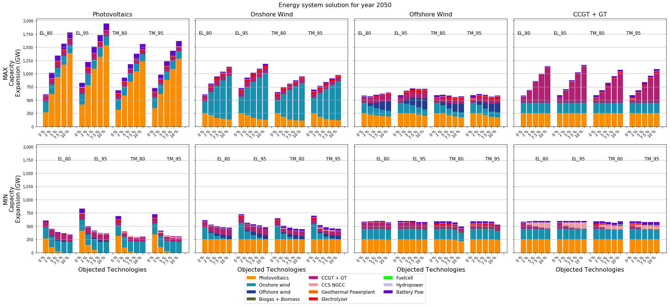

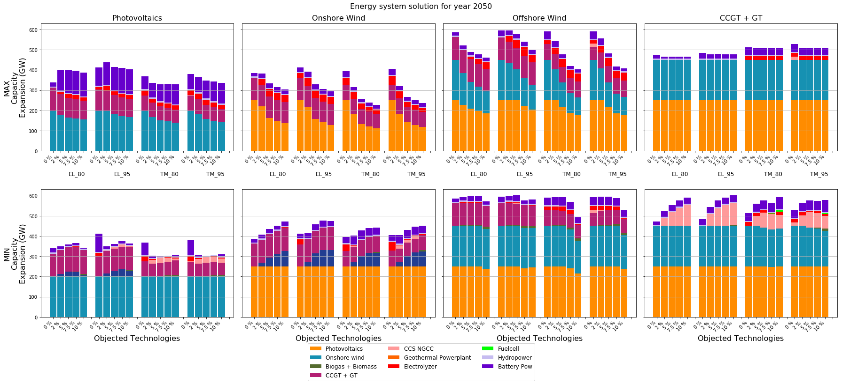

* Capacity maximization için minimum total capacity offshoreda var çünkü offshore supim commodity olduğu için wind olduğu sürece elektrik üretmek zorunda ve offshoreun flhu çok yüksek. Yani elektrik üretimi bir hayli fazla. Bu nedenle digger proceslerin capacityleri az build ediliyor.

However attention must be drawn that this model designed as a single node, which means it is assume that for all timesteps capacities of transmission lines from offshore turbines to grid is sufficient.

This model is designed single node although it reduces the resolution of the model, because 1024 near optimal and 64 optimal solutions are run. There fore aim of this study is to analyze maximum possible near optimal search directions with available computational resources

* Among all minimization solutions, minimizing PV capacity gives the minimum total capacity, that can be explained with scanty of photovoltaic full load hours. Since replacing renewable capacities has higher flhs less capacity is needed to meet the same demand.
* Increasing PV capacity does not decrease onshore or gas much

Reason: lower flh and cost of pv. (probably production of gas is decreasing)

* increasing onshore capacity mainly decreases pv capacity. Because FLH of onshore is higher
* Increasing offshore capacity reduces both onshore and pv significantly. Because of FLH
* Decresing pv capacity results in increasing offshore , onshore capacity is always at potential limit
* Decreasing onshore will result in increasing offshore pv capacity is always on potential limit border
* During minimizing gas technology onshore and pv are already on the border therefore they can not increase, offshore also does not increase instead of that existing gas pps replaced with ccs powerplants and electrolyze is build
* Electrolyzer increases with maximizing onshore and offshore
* Intechnology mix scenarios same cost increase yields in a more divesre technology mix, especially wrt use of electrolyzer and ccs the reason for that is (reduced demand? Reduced budget?)
* When PV OR Wind on maximized total capacity increses and when minimized decreases, that is due to relative low flh. However minimization and maximization does not change total capacity too much for gas and offshore. That is because these two act like base capacities
* Battery capacity increases with pv maximized most
* Elec capacity increases with onshore wind offshore wind maximization most
* Gas capacity replaced with ccgt when minimized

Lower – Upper Half: (bunu da 1 4 lü grafikte hep aynı objected olacak şekilde yapabilirsin

PV:

Battery capacity drops when PV minimized but in TMs increases again after 5%

Battery capacity increases as pv maximized (onshore doesnot change pv increases)

!!!!!!! Electrolyzer drops when pv minimized and increases after 5% (wind onshore can not increase due to limit, after 5 % pv capacity reaches 0)

Electrolyzer capacity first drops than increases around 5% because total capacity drops a lot but after 5 % pv capacity reaches 0

Reason:

Onshore:

Battery does not change when onshore minimized

Battery does not change much as onshore max (aslında pv capacity bayaa düşüyor)

Elyzer drops when onshore minimized (pv is at limit offshore increases total renewable capacity and total capacity drops )

Elyzer increases for smaller slacks then it drops for ELs it remains constant and for TM (I really don’t know why)

Offshore: since this is 0 systems does not change much , offshore capacity does not change as offshore minimized only extra cost changes the mix

Offshore minimized Battery remains same (offshore does not change as offshore minimized pv an onshore are on limit does not increase)

Battery tends to remain same for ELs and drops for TMs when offshore maximized

Offshore minimized Elyzer remains same

Offshore maximized elyzer increases (sanıım offshore maximized olunca windlerin total flh x capacitysi artıyor )

Gas :

Gas minimzed battery increases a bit of TM s only

Gas minimized electrolyzer does not change much since PV and wind capacity are at limit off shore does not build but since base capacity is not there more storage needed.

Elyzer and battery capacity increases frm 80 to 95 in general however for ELs this change is more than TMs

In TM scenarios battery storage and electrolyzer capacity are more dominant

REMARK:Emission policy affects solution for EL scenarios more than TM scenarios.

REMARK: Storage capacities also increases in absence of base capacities

Remark: Battery storage is strongly connected with PV but also has positive correlation with offshore and onshore

Remark: Battery capacity needed stays high and constant as (onshore offshore or gas minimized, since pv capacity does not change due to limit)

# Heat Maps:

(heat mapslerde minimization alırkenobj 0 landıktan sonraki slackleri almadan çizdir.)

PV

Electrolyzer and battery has strong positive correlation with PV

Biogas and geo has negative relation with pv

CCS and PV has no remarkable correlation

Wind on

Electrolyzer has positive correlation with wind

!!!!! does not match with lower half graphs Battery power has positive correlation with onshore when onshore increases, no correlation when decreases

Geothermal and bio has negative correlation when onshore increases, no correlation when decreases

CCS has no correlation

Offshore:

We will look only offshore max: (for offshore min everything is opposite but it is because no offshorewind capacity dıesnot drop asslack increases it is always 0

Electrolyzer has a positive correlation

Battery has a positive correlation

Geo bio negative

CCS no correlation

Gas:

We are only interested in gas min. For max everything is opposite because when gas maximized just its capacity increases and nothing else changes much

Elyzer battery negative

Geothermal biomass positive,

CCS negative

# Envelopes

* Building offshore wind turbines economically viable only after exploiting on

 shore and pv potential fully.

* Gas capacity is not much correlated with other technology capacities. However it is slightly more correlated with PV capacity change
* Offshore capacity is most sensitive to changes in onshore capacity
* Onshore capacity is more sensitive to changes in offshore capacity
* PV capacity is most sensitive to onshore capacity changes
* Gas capacity needed for TMs are much lower
* Feasible space of technologies (usually) increases with time
* Pv has the biggest feasible space then onshore then gas than offshore

# Minimum Cost Solutions

(4 grafiği birleştirip ci=1 ile her objectiveiçin tek line çizdirebilirsin)

For minimum cost solutions of different scenarios as objected technology changes demand and budget stays same but potential limit of the objected technology is lifted and let to expanded by the model(16 solutions x4 years)

* More battery storage capacity is buils as PV increases
* Less battery storage capcity is built as onshore increases (it can be because elyzer is substituting the storage function)
* Electrolyzer capacity increases both with more wind on and pv. However with wind lifted it increases even more. This tells us: Pv increases wind on does not changes, elyzer icrease is alsorelated to pv increase, as onshore wind increases. As onshore increases pv does not change but elyzr increases even more. Electrolyzer increase more related to onshore than offshore
* Electrolyzer capacities are more in TM scenarios
* Increase in elyzer capacity is higher for TM scenarios.
* Tm scenarios are less sensitive to emission policy
* Offshore capacity is insignificant for minimum cost soutions
* Gas capacity stagnates and decreases with time for minimum cost scenarios and it decreases more fot tm scenarios.

# Specific Emission

# Absolute Emissions

Feasible spaces (effect of potential limits and flexibility)

Relation among capacities

capacity storage relations

scenario capacity storage relations

emission target capacity storage relations

scenario emission relations

scenario cost relations

REMARKS ABOUT CAPACITIES:

# Remarks

* In this study 256 near optimal and 16 cost minimization set-ups are run and in total 272 different solutions are found where each solutions has a resolution of 35,040 hours from 4 modelled yearsand represents development of electricity generation system of Germany for 50 years. . This is done in order to see the effect of limits set by legislations and technical potential on technology mix and in order to observe full range of flexibility created by allowed percentage cost increases on the system.
* Photovoltaic panels, onshore and offshore wind turbines, hydroelectric powerplants, geothermal power plants, biogas and biomass power plants, electrolyzer and fuelcell units, gas turbines, CCS natural gas turbines,hard and brown coal power plants , battery ,hydrogen and pumped hydro storages are modeled units of the model.
* Among those units photovoltaic panels, onshore and offshore wind turbines, hydroelectric power plants, geothermal power plants are modeled in a way that, they must produce electricity as soon as their input commodity is available. Availability of respective commodities are given as hourly timeseries input to the model. Those commodities and processes are called intermittent supply commodities and processes. Electricity production of intermittent supply processes are directly proportional with their installed capacities and full load hours can not be altered by the solver. Production inflexibility of intermittent supply processes serves as a substitute to unreliable nature of capacity factor of renewable sources in real life.
* On the other hand, other processes can be turned on or off by optimization whenever needed, therefore their electricity production is not directly correlated with installed capacity. Their full load hours and electricity production might differ drastically among different solutions in spite of similar installed capacities.
* Coal power plants are modeled to be demolished by 2040 as planned by new coal phase out law.
* For analysis installed electrolyzer capacity can be directly interpreted as installed H2 Storage power, since efficiency in and out of H2 storage is assumed to be one and electrolyzer is the only process in the model to produce H2 from excess electricity.
* Relative emission budget decrease from TM80 to TM95 is 5 % while from EL80 to EL 95 is 13 %. Since emission share of electricity generation sector is lower in TM scenarios, emission mitigation share is also lower. This is the main reason behind weaker reaction of TM scenarios to environmental policy changes.
* Relative demand increase between TMs is 2 % while between ELs is less than 1 %
* Relative minimum cost increase between TMs 4 % ELs 2 %

## COST

* scenarioların min costu farklı dolayısı ile cost allowancelar de percentage bağlı olduğu için aynı slack için absolute cost increase de farklı
* EL scenarios gives lower specific cost than TMs. This phenomenon can be explained by economics of scale. Due to high electrification in many sectors, electricity demand of EL scenarios are much higher. Cost increase due to additional capacity build in order to meet demand is lower than demand increase itself.
* More ambitious environmental policies are observed to have slightly higher specific electricity cost, however this difference is small compared to the increase by decreasing electrification.
* Changes in specific cost between different optimization directions and objected technology capacities are negligible, while specific cost increases linearly with increasing slack.
* Although additional cost constraint added for near optimal solutions is smaller or equal to the allowed cost limit. We observe cost limits are exploited to the limit for both optimization directions.

## Capacity relations

* Geo bio , fuelcell az çıktı önemli değil
* Hydro ve pumped neredeyse capupa kadar kullanılmış ve ömürleri uzun o yüzden onlar sabit.
* H2 storage ve battery ilerleyen zamanda en önemli 2 storage olacak. H2 electrolyzer ile temsil edilsin
* CCS gası substitute edebilecek peak load capacity olarak potansiyeli var
* Total capacityleri minimize etmek için gerekli mariginal cost artışı Tmlerde gaz için daha düşük
* As environmental policy target gets more ambitious mariginal costs of replacing gas turbines capacity with ccs decreases.
* Onshore için en az 10% pv için en az 7.5 % gerek. Total wind capacity her zaman olmak zorunda.

## Renewables maximized minimized

* As total installed PV and onshore wind turbine capacities increases, total installed capacity to meet the same demand decreases. In bar plot it can be seen that lowest total installed capacity is achieved either by minimizing offshore or PV capacities or maximizing offshore wind capacity. The reason for letter is high full load hours offshore wind commodity. As less capacity needed to produces same amount of energy from offshore wind and due to high full load hours and intermittent supply nature of offshore wind turbines, installed onshore and PV capacity decreases significantly as offshore wind turbine capacity maximized.
* Similarly as installed onshore wind capacity maximized PV capacity decreases and as PV capacity maximized installed onshore wind turbine capacity decreases, however the letter decrease is relatively small relative to decrease of PV when Onshore maximized or decrease of PV and onshore wind as offshore capacity maximized.
* Here attention must be drawn to the fact that, in this study energy system is modeled as single node due to computational effort restrictions, which means model assumes that for all time steps modeled capacity of transmission lines from offshore turbines to grid is sufficient.
* Gas turbines and CCS natural gas power plants serve as peak load capacities in the model. Their electricity production can be scaled independent of installed capacity. As amount of total electricity produced by renewable energies increases, installed gas turbine capacity doesn’t change much however as can be seen from electricity production plot, electricity produced therefore full load hours of gas turbines decreases with increasing total renewable electricity production and increases with decreasing total renewable electricity production.
* On the contrary, as PV or Onshore wind capacity minimized, the capacity of the other cannot increase due to technical potential and social acceptance limit. Instead, as PV capacity decreases FLH of gas turbines increases and as onshore capacity decreases more offshore wind turbines are built together with increasing gas turbine full load hours.
* Offshore minimum cost için build edilmiyor. Solver offshore build etmeden önce pv ve wind potentialını sonuna kadar kullanıyor. Bu yğzden offshore minimization zaten 0dan başlıyor
* Tm lerde gaz kapasitesi EL lere gore daha düşük (budget düşük, demand düşük) ve TMlerde elyzer cccs ve bttery capacityleri daha fazla
* Changes in capacities in lower electricity sector share scenarios (TM) are less sensitive to environmental policy targets. That can be due to lower relative change of (absolute cost increases,demand or budget) between different environmental policies in TM scenarios.
* From the minimum cost graphs it is observed that
* Gas capacity stagnates or decreases with time even before being objected to minimization with extra cost allowance. This shows clearly that in order to meet environmental targets of 2050, building extra gas turbine capacity should be avoided.

## Storage vs Capacities

* As peak load capacities decreases in energy system, need for storage systems increases. Therefor as gas capacity minimized installed battery power and electrolyzer capacity are tend to increase
* On the other hand, installed battery storage power and electrolzer capacity are positively correlated with photovoltaics, onshore and offshore capacities. Since those processes are intermittent supply processes sometimes they produce more electricity than demand therefore excess electricity needs to be stored for meeting peak demand hours where not enough renewable commodities are available for use. Therefore all renewable capacities are positively correlated with all storage powers.
* However among storage technologies installed battery storage is more strongly correlated with photovoltaics capacity while installed electrolyzer capacity is associated more with wind capacities.
* Çünkü power capacity dengesi
* In general due to high full load hours installed offshore wind capacity does not require as much storage capacity as other renewables.
* Peak load capacity gibi hareket ediyor
* Technology mix (TM) scenarios in general has more installed battery power and electrolyzer capacity than electrification scenarios. Because TM scenarios has less gas capacity in the absence of peak load more storage capacity is needed.
* As emission mitigation goal increases, installed capacity of storages also increases. That is du to increasing share of renewable energies against peak load capacities in energy system, and in addition to that increasing absolute cost of the system.
* From the heatmap it can be seen that processes forms 2 main groups Geothermal pp, Bioenergy and Gas Turbine capacity are positively related among each other while they are negatively related to the second group which consists of photovoltaic panels, onshore and offshore wind turbines, electrolyzer, battery storage and CCS natural gas turbine capacities

## Feasible Space

* From the feasible space plots it is observed that feasible space of more aggressive environmental policies (95) are wider than less aggressive environmental policies (80) among same electricity sector share policies (TM and EL). Reason for that is the difference in absolute cost increase. As environmental policy becomes more aggressive or share of electricity generation sector increases, respective minimum cost, therefore absolute cost increase for same slacks. Whit this extra cost, solver is able to build more capacity of maximized technologies or replace objected capacity more with more expensive processes as it is minimized.
* Similar reason applies for explanation of difference in feasible spaces of different objected technologies inside same scenario. As explained above inside same scenario minimum cost and absolute cost increase with same slacks are same however feasible space of PV capacity is wider than onshore wind capacity, and that from offshore wind capacity because with the same extra money solver can build more capacities from cheaper technologies.
* From the feasible space plots it is also observed that solver tends to build more PV and onshore wind turbine capacity than technical and social acceptance potential when allowed even for minimum cost solutions. This shows us that currently binding potential limits for pv and onshore [references] must be hoisted by policies. Wider land use of PV and onshore wind turbines should be faciliated.
* Non linear shape of feasible spaces of renewable technologies shows dependencies of those capacities to each other. This is due to the production inflexibility of intermittent supply technologies. On the other hand gas capacity changes linear with absolute cost increase because electricity production of gas turbines can be controlled independent of installed capacity
* Span of feasible spaces of lower electricity sector share scenarios (TM) are less sensitive to environmental policy targets. That can be due to lower relative change of absolute cost increases between different environmental policies in TM scenarios.
* As investment cost of renewable technologies are modeled to fall over the course of modeled years, most of the new installations of maximized technologies are done at the last modeled year where investment costs are lowest and demand is highest.
* This can be observed strongest on the envelope graph of offshore wind energy. Here minimization or maximization does not create a feasible space up till 2050, and at 2050 due to falling prices and full exploitation of PV and onshore wind potentials. Upper border of feasible space lifts while lower border of feasible space is at 0 installed capacity even for minimum cost solution.
* Again form the envelope plots we can interpret feasible spaces of gas turbines are not sensitive to change in other renewable capacities. However as mentioned before electricity production from gas turbines has a strong negative correlation with installed capacities of other objected technologies
* Feasible space of PV capacity is most sensitive to onshore capacity , while onshore’s and offshore’s are most sensitive to each other.
* Gas capacities required for lower electricity sector share scenarios are much lower than higher electricity sector share scenarios. This is due to lower demand and budget of the first one.

## Emissions

* In introduction section two main environmental targets for Germany are introduced; first one is to reduce total CO2 eq emission of Germany up to 80% to 95% below compared to 1990 levels and second is to facilitate an almost emission free electricity generation sector of Germany by 2050. In addition to above mentioned two main emission targets, it is desired to catch a decreasing yearly emission trend by 2050 in order to secure emission mitigation of the system in the future.
* In this study CO2 budget approach is adopted to force first target on scenarios of the model instead of common yearly Co2 limit approach. Advantage of budget approach over limit approach is that, although total allowed CO2 emission through the model horizon is same for both, CO2 limit approach is not flexible at allocating emissions freely over the course of modeled years. Therefore results do not secure an energy system with almost zero emission by 2050.
* On the other hand with a budget approach, available emission budget can be allocated to modeled years more effectively. However resulting energy system might have a increasing trend at the end of the modeled year.
* All scenarios meet the first environmental target, in order to select solutions which also meets the second target and has a still decreasing emission curve, 10 M ton yearly emission line is drawn on plots. Scenarios which reach this line by 2050 are counted as almost zero emission scenarios.

Burada absolute emmissionlara da değinmek lazım. minimizationlarda objected technologynin total capacitysi çoğunlukla son yıllarda azalıyor veya artıyor. Eğer demand gas full load hour arttırılarak karşılanırda (pv win minimizationda olduğu gibi) son yıldaki yıllık emission çok daha yüksek olur

* Specific emissions of technology mix scenarios are lower than electrification scenarios. This is mainly due to lower demand.
* From specific emission graph it is seen that, CO2 budget set is fully exploited for all solutions in technology mix scenarios.
* An other trend can be observed from specific emission graph is that more ambitios the environmental policy target is less the specific emission of the energy system.
* Only for the electrification scenario with lower environmental target , specific emission tends to change with slack, optimizing direction and objected technology
* For this specific case, maximizing onshore wind reduces specific emission strongest for lower slack values while lowest specific emission is achieved by minimizing gas turbine capacity with 10 % cost increase. Here attention must be drawn that by gas turbine capacity minimization with 10 % slack, gas turbine capacity is being replaced completely by ccs natural gas, therefore it is crucial to reduce dependency of the energy system to traditional gas turbine power plants in order to reduce emissions radically.
* In this study carbon budgets of scenarios are determined by relaxing emission limits of corresponding scenarios in [DENA] study. In other words, same scenarios emits same amount of CO2 equivalent along model horizon however, in this study allocation of emissions to years are not pre-determined, but made by optimization . By means of this relaxation emission mitigation trend of energy system over model horizon can be observed. This phenomena can give consequence to positive sloped parts of emission plot with respect to modeled years. Indeed optimizations in this study produce upward facing parabolic emission curves.
* If global minima of emission curve is located above zero emission or before model horizon, although emission from electricity generation sector will stay below its share of emission budget till 2050, emissions will keep on increasing after model horizon.
* In co2 comparison plots emission curves found by this study is given together with pre-defined emissions of DENA study. Above mentioned trend can be observed clearly from co2 comparison plots for all scenarios for cost minimization solutions.
* [Co2 near optimal] shows absolute emission of scenarios and objected technologies at different slacks and optimization directions.
* Plot for minimum cost shows that as potential limit of pv and onshore wind lifted global minima shifts down and right, therefore it is possible to catch a still decreasing trend in emission by 2050. Unless current realizable potential limit of pv or onshore wind is relaxed, minimum cost energy system solutions can not result in an almost co2 free electricity generation by 2050 as targeted. As emission mitigation target gets more ambitious, effect of hovering potential limits becomes more apparent.

* Due to lower Co2 budget TM scenarios are located lower than EL scenarios. As slack value gets bigger, 2050 emission of EL scenarios converges to TM scenarios. Which means that emission curve of EL scenarios has steeper negative slopes.
* As slack value increases global minima shifts down.
* Among all solutions presented in [near optimal co2]
* Minimizing gas turbine capacity is found to be one valid strategies for satisfying both of the targets with a still decreasing emission trend. While TM scenarios environmental targets are satisfied with less than 2% mariginal cost increase, for EL scenarios this mariginal cost increase is around 10 %. It can be interpreted that it is crucial to reduce dependency of the energy system to traditional gas turbine power plant in order to reduce emissions radically.
* Similarly maximizing renewable capacities are also valid strategies, for satisfying environmental targets. Both targets can be satisfied at a 5% slack for TM scenarios .
* For each scenario by maximization of renewables , onshore maximization solution result in a lower emission than pv maximization solution and that than offshore wind solution. Although all three solutions has same demand, budget and allowed system costs, their emission trends are different because of the variation of electricity generation from gas turbines among these solutions. Electricity produced from gas turbines is lower when objected technology is onshore. Altough maximization of offshore technology gives the least cumulative installed power capacity among all renewable maximizations, generation from gas turbines is highest.
* On the other hand most environmental friendly way to reduce onshore wind turbine capacity without falling too far away from cost minima is investing in offshore capacity while keeping electricity demand low.

Policies

1. 10h ve pv land use rules must be relaxed in order to meet emission targets sustainably more economically …

2. As offshore wind cost progression will continue as assumed in this model. It will never be economical to build over pv and onshore even though it has more flh. Building offshore wind turbine will always daviates from minimum cost solutions.

3. CCS technology has a great potential for replacing gas turbine fleet as peak load capacity with much less CO2 emission. Results of this study shows that, investing in safer carbon storage technology research is important to meet 2050 environmental goals while securing electricity supply.

4. Battery and Hydrogen storage will gain an important role as german energy policy deviated form conventional technologies and relies more on intermittent supply technologies. In case of a possible future consideration of natural gas phase out, high investments on battery, electrolyzer and fuelcell is crucial. However currently predicted (değerler cost efficiency vs) shows that development in these technologies are not competitive enough to secure energy supply at peak demand for germany.

5. it is crucial to reduce dependency of the energy system to traditional gas turbine power plant in order to reduce emissions radically.

6. most environmental friendly way to reduce onshore wind turbine capacity without falling too far away from cost minima is investing in offshore capacity while keeping electricity demand low.